A Sustainable Electric Bicycle Scheme for Edinburgh
  - Benjamin de Sousa, Alexandros Zachakos, Todd House & Nolan Willoughby
  - MMCS Consultancy Project

Contents
1 Introduction 3
1.1 Historical Context 3
1.2 Objectives 3
1.3 Deliverables 3
2 Modelling Approach 4
2.1 Assumptions 4
2.2 General Sets and Notation 4
2.2 Base Model 4
2.2.1 Parameters 4
2.2.3 Constraints 4
2.2.4 Objective Function 4
2.3 Extended Model 4
2.3.1 Parameters 4
2.3.2 Variables 4
2.3.3 Constraints 4
2.3.4 Objective Function 4
3 Results 4
4 Conclusion 4
5 References 4
6 Appendix 5

1 Introduction
The city of Edinburgh is comprised of many winding and tight streets befitting its ancient origins. As such it is well serviced by a host of public transport options that help to reduce the load on its infrastructure. However, there is a lack of more personal public transport options in the city. This results in the limits to the coverage that the public transport can provide due to the nature of the city’s roads as well reducing the possible effect on traffic numbers. This report aims to provide a solution, titled “E-Bike Edinburgh,” to this problem with the reintroduction of an electric bicycle scheme that would be supported by the city council and a consortium of local employers.
  - Historical Context
Edinburgh has experienced a generally consistent rise in road traffic over the past 30 years. There has been an increase of 376.9 million^{[2]} miles of vehicle travel per year over that period. To contrast, Edinburgh’s air pollution has been steadily improving, with NO₂ levels dropping by ~10µg m⁻³ in the period of 2007-2023^{[3]}. However, Edinburgh has still yet to hit its 2030 net-zero target^{[4]} and is still looking for ways to accelerate towards it. Both of these factors would be greatly aided by the reintroduction of a cycle hire scheme.
This report frames the proposal as a reintroduction because Serco, a multi-sector firm, ran a cycle hire scheme in Edinburgh between 2018-2021^{[1]}. Whilst relatively successful with 95^{[1]} stations constructed and 423,000^{[1]} trips serviced over the period, it eventually was closed due to financial challenges. This report hopes to justify the new scheme through the careful application of a mathematical model that accounts for the flaws of the previous scheme whilst providing clear and substantial improvements in the service provided.
  - Objectives
The key objectives of this project will be structured within an ESG framework. This should allow for the greatest return on investment as well as the greatest benefit to the community.
- Environmental
  - An increase in the number of bicycle trips leading to a reduction in motor vehicle traffic
- Social
  - A vastly increased rate of coverage by the scheme allowing for a larger number of users to benefit from it
- Governance
  - A reduction in infrastructure costs for the Council due to reduced road traffic and an employee subsidy for the scheme for the consortium
  - Deliverables
The three key deliverables for the base model would be:
- Number and size of stations constructed
- Number of bikes produced
- Selection of station locations
Further factors and objectives will be considered in the extended modelling approach discussed later in this report.

2 Modelling Approach

2.1 Assumptions

2.2 General Sets and Notation

2.2 Base Model

2.2.1 Parameters

2.2.3 Constraints

2.2.4 Objective Function

2.3 Extended Model

2.3.1 Parameters

2.3.2 Variables

2.3.3 Constraints

2.3.4 Objective Function

3 Results

Base Model
The base model generates a solution of opening 142 of the 250 candidate stations across three months. In the first month, 27 stations are opened with 1440 bikes and 288 hangars. In the second month, 21 stations are opened with 865 bikes and 173 hangars. In the third month, 94 stations are opened with 572 bikes and 116 hangars. In total the stations contain 2877 bikes, and 577 hangars. This monthly rollout would allow the highest demand stations to be opened first to generate excitement and begin recouping the initial investment. This can be seen in the station to bike ratio for the three months. The model opens the smaller stations later to begin to maximize bike availability and cover more POIs after the highest demand locations are covered.
Each hangar is fitted with 6 docks that allow users to lock the bikes during return. The stations range from 5 to 55 bikes depending on expected demand with a maximum dock space for 66 bikes. Most of the larger stations are located around the city centre with a few spread across outer neighbourhoods. A density spike plot of the bikes by station is shown in figure #. All candidate solutions are shown with red spheres, and the blue spikes are proportional to the number of bikes assigned to that station. This solution uses all the initial proposed budget of £3,750,000.
The following estimates are based on the monthly data of the 142 stations opened. Pricing for the scheme is baseline planned as £1.50 to unlock the bike and £0.10 per minute of use. These values are within the range of the previous scheme and the ongoing VOI trials. Running the scheme with an estimated 64,442 monthly trips and an average trip duration of 32.44 minutes results in an estimated monthly revenue of £305,607.40. The time required to recoup the initial investment, without considering overhead costs or other operating expenses, is approximately 13 months. Given the focus on optimising POI coverage, the cost model was not a focus of the model analysis. Possible avenues exist to reduce this cost plan to the consumer such as providing employee discounts for those of contributing companies, monthly plans, or routine usage discounts.
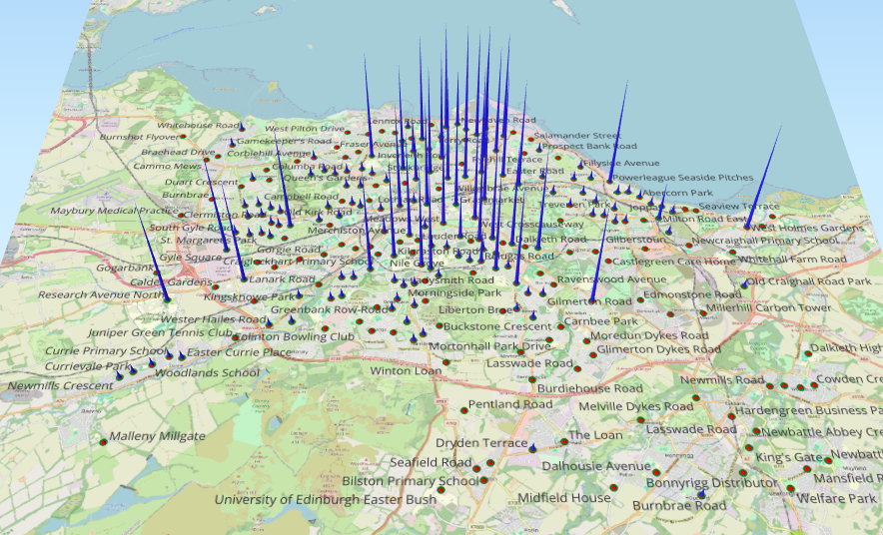
Figure X. Bikes by Station
Given in The City of Edinburgh Council budget for 2025/26 the carriageway and footways work accounts for £18.16 million or 71% of the available funding[##]. https://democracy.edinburgh.gov.uk/documents/s82577/8.1%20-%20Roads%20and%20Infrastructure%20Investment%20-%20Capital%20Delivery%20Priorities%202025_26.pdf The reduction of traffic driven by a successful intracity bike scheme could produce significant cost savings for the Council. Denmark ranks #2 in happiness, 90% bike ownership, notably, cycling accounts for 21% of trips under 10 kilometres and 15% of all trips in Denmark, showcasing its versatility as a mode of transport[##].https://roadandmountainbikereviews.co.uk/25-striking-cycling-statistics-in-denmark/
If Edinburgh can capture a similar travel ratio, it could save the Council upwards of £4 million annually. Regarding the hangar’s feasibility, the city already has 200 bike hangars on streets and is interested in expanding the count. This is evidence of a successful product that users choose to pay into to increase bike security and reduce weather effects.

3.2 Extended Model

3.3 Maintenance Tool
Provided in Appendix # is a mock-up of a maintenance forecasting and scheduling tool developed to enable long term maintenance activities to be planned effectively. This tool is modular and can be updated to accommodate changes to bikes allocated to each station and changes in number of stations open. The tool allows you to dynamically filter to see how many bikes are at any given station, how many maintenance hours, by category, are needed for each station. Furthermore, the tool has the basis for annual scheduling by station to allow planners to schedule maintenance around demand windows, especially seasonal fluctuations. Such scheduling is essential to ensure the highest quality product while maximising bike availability while being flexible enough to allow for unexpected events resulting in the need to remove bikes for critical maintenance.

4 Conclusion
E-Bike Edinburgh provides a proven system capable of reducing traffic and NO₂/CO₂ emissions while providing an effective alternative to existing public transportation infrastructure. The bike rental scheme will provide an option to health-conscious commuters for daily travel at low cost to the Council. The scheme also provides the opportunity for companies to contribute as part of carbon offsetting initiatives. Such contributions could enable the scheme to give special benefits to employees of those companies, such as discounted rates.

5 References
[1] – Edinburgh Cycle Hire, Edinburgh Cycle Hire, Serco, Accessed 10 November 2025
[2] – Road traffic statistics – City of Edinburgh, Road Traffic website - City of Edinburgh, UK Government, Accessed 10 November 2025
[3] – Data Trends Summary, Trends summary, Air Quality in Scotland, Accessed 10 November 2025
[4] – Edinburgh’s net zero target, Edinburgh's net zero target – The City of Edinburgh Council, The City of Edinburgh Council, Accessed 10 November 2025

6 Appendix

